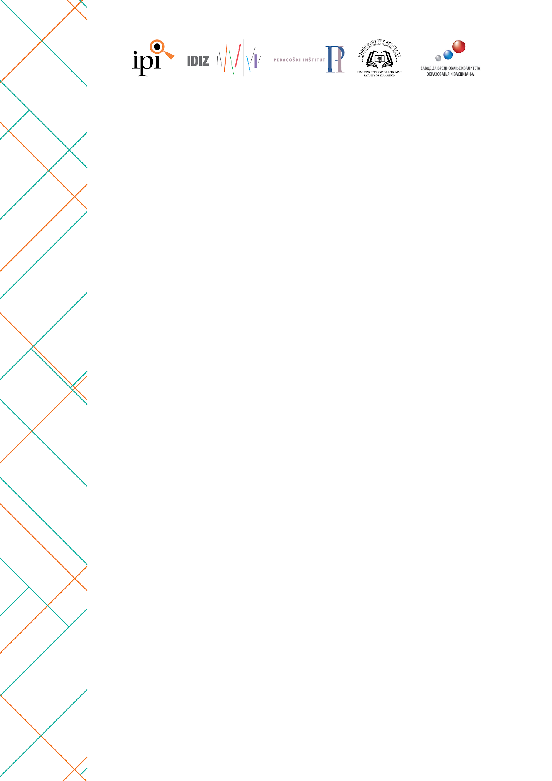

The 31st International Scientific Conference
“Educational Research and School Practice“
ICCS 2022: Results and implications

APPLICATION FORM

The application for participation in the Conference is to be submitted no later than October 1, 2024 at: ierconference2024@gmail.com

Name, surname, title
Occupation
Institution
Telephone
E-mail
*If there is more than one author, please copy and fill this table for each one of them.

Title
Key words (up to five)
Conference topic

ABSTRACT TITLE

Abstract (in English, font Times New Roman, 12pt, 1.5 line spacing)

